Thermal vs. Sound Energy

by Quang Huynh

There are many forms of energy being used in our planet every day. But I am going to be comparing two energies, thermal energy between sound energy. Both energies are very interesting and unique. Now, let’s talk about the two energies. Thermal Energy is energy that comes from heat, and this heat is generated by the movement of tiny particles within an object. The faster the particles move; the more heat is produced. Next, Sound Energy is the energy associated with vibrations of matter. So that is basically a summary of what these two energies are about, Sound and Thermal Energy.

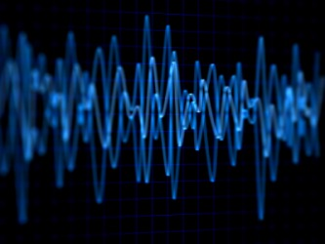

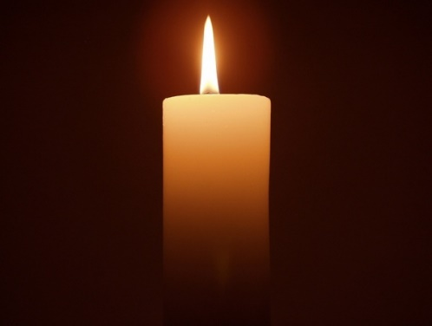

* Firstly, let’s compare on how Sound and Thermal Energy are similar. They are both Kinetic energy, meaning they are both from the movement of a wave or particle. They also move through solids, and carry energy. But also, they are both very different from each other, for example, Thermal Energy uses Joules as its unit, and Sound Energy is measured in decibels and pascals. Thermal and Sound Energy are also different by the fact that Thermal Energy is energy from heat and the heat is generated through the movement of particles, and Sound Energy is through the movement of mechanical waves. Some facts are, If the vibrational waves of a medium changes, the sound it produces will also change. Also, another fact is, Sound produces a low level of energy. Then, the joule is the unit used to measure thermal energy. Next, Sound is measured in decibels and pascals. After that, Sound energy is a type of mechanical wave which means it requires an object to travel through. Finally, the energy that comes from heat; generated by the movement of tiny particles within an object.

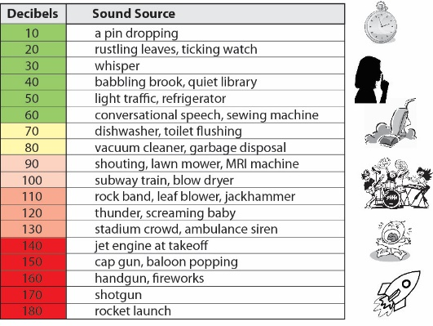 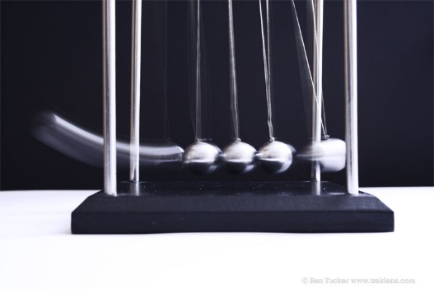

Now let’s talk just about Thermal Energy. So, Thermal Energy is energy that comes from heat, which is generated through the tiny particles in an object. The faster these particles move, the more heat is generated, making more energy. Thermal Energy is measured using Joules. Thermal Energy is transmitted to or from an object, being transferred as heat. Some interesting facts about thermal energy is that, objects do not obtain heat, instead, they obtain thermal energy. Another fact about thermal energy is, the amount of thermal energy depends on the temperature, but also depends on the amount of matter you have. Lastly, thermal energy is a part of the total energy of any object.

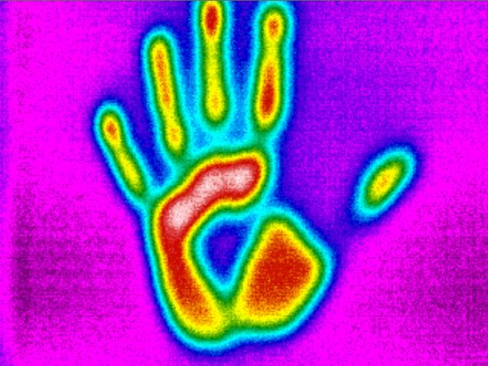

Next, let’s talk about Sound Energy. Sound Energy is the energy that’s associated with vibrations of matter, and is a type of mechanical wave. Sound comes from the vibrations that result after an object applies a force to another object. Also, since sound produces such a low level of energy, it is not used for electricity, and sound is measured in decibels and pascals. The 4 amazing facts about sound energy are, If the vibrational waves of a medium changes, the sound it produces will also change. Also, Sound is measured in decibels and pascals instead of the tradition unit of energy measurement, the joule. Next, because sound produces such a low level of energy it is not used for electricity. Finally, Sound produces a relatively low level of energy when compared to other forms of energy.

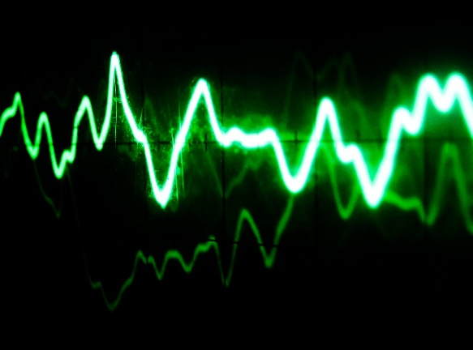

So, comparing Sound Energy and Thermal Energy, you can see there are some similarities, but there were a lot more in the differences. We can learn from this compare and contrast essay that Sound and Thermal energy are both kinetic. Also, you can learn that sound produces a low amount of energy, so it could not be used as electricity. Next, another thing that you could learn was, objects do not obtain heat, but instead, they obtain thermal energy since heat is a process. Either way, these two energies are both very different, but also similar.

Works Cited

“Thermal Energy Facts.” Science, [www.softschools.com/facts/energy/thermal_energy_facts/402/](http://www.softschools.com/facts/energy/thermal_energy_facts/402/)

“Sound Energy Facts.” Science, www.softschools.com/facts/energy/sound_energy_facts/401/.